MATH 243 — Probability and Statistics
Skewness, Moments and Kurtosis
Lesson notes · Exam approach · TF practice with solutions · Quick notes (Statistics portion)

How to Read These Notes
EXAM FOCUS | Exam importance, where it appears in the TF collection
MEMORIZE | Rules, tables and formulas to memorize
TRAP | Common mistakes and exam traps
EXAM-READY ANSWER | Model wording you can write in the exam
NOTE | Extra explanation / clarification
Grey box, monospace | Code, worked tables, derivations and hand-drawn sketches
Centered grey box | Formula to remember / final numerical result
Purple heading / ✔ green | Practice questions / their solutions

Contents
Exam Map — What the TF Papers Ask — the single most repeated Statistics question
Lesson 10 — Skewness: Pearson, Bowley and Kelly Coefficients — shapes, three coefficients, interpretation
Lesson 11 — Moments, β₁, β₂, γ₁, γ₂ and Kurtosis — raw → central moments, kurtosis, all TF tables solved
Quick Notes — Skewness, Moments and Kurtosis — revision bullets
NOTE Page numbers refer to 4. Skewness, Moments and Kurtosis.pdf (15 pp.), written as p. n. Grouped working uses the slide method: d = (x − A)/h, μ'_r = (Σfd^{r}/N)h^{r}. "TF p." = merged question PDF page; "22 batch p." = 2023-24 paper.

Exam Map — What the TF Papers Ask
Session (paper) | Questions answered by this note [lesson]
2023-24 (MATH 243)  TF p. 22 batch p.3 | Q6(a) Marks 0-10…60-70 (f 8, 12, 20, 30, 15, 10, 5): four central moments, β1, β2; comment (13) [L11]
2022-23 (MATH 243)  TF p. 50 | Q6(a) Define and illustrate SD, variance, skewness, kurtosis, moments (10) [L11] · Q6(c) Profits 10-20…50-60 (f 18, 20, 30, 22, 10): four moments about assumed mean → about mean; γ1, γ2 (15) [L11]
2020-21 (MATH 245)  TF p. 37 | Q5(b) Weights 30-40…80-90 (f 18, 37, 45, 27, 15, 8): Bowley's and Kelly's skewness; merits and drawbacks (15) [L10]
2019-20 (MATH 245)  TF p. 34 | Q5(b) Earnings 50-70…170-190 (f 4, 8, 12, 20, 6, 7, 3): four moments about assumed mean → about mean; γ1, γ2 (25) [L11]
2018-19 (MATH 245)  TF p. 24 | Q5(b) What are skewness and kurtosis? γ1 and γ2, classes 10-20…50-60 (f 18, 20, 30, 22, 10) (20) [L11]
2016-17 (MATH 245)  TF p. 20 | Q6(a) Define skewness and kurtosis; coefficients by moments, profits 10-20…50-60 (f 18, 20, 30, 22, 10) (17) [L11]
2015-16 (MATH 241)  TF p. 15 | Q7(a) Coefficients of skewness and kurtosis, classes 10-20…50-60 (f 174, 86, 32, 181, 27); comment (18) [L11]
2014-15 (MATH 241)  TF p. 10 | Q6(b) Karl Pearson's skewness and β1, β2, classes 10-20…50-60 (f 18, 20, 30, 22, 10) (18) [L11]
2013-14 (MATH 241)  TF p. 7 | Q6(b) Coefficients of skewness and kurtosis, classes 10-20…50-60 (f 174, 86, 32, 181, 27); comment (20) [L11]
2012-13 (MATH 241)  TF p. 5 | Q6(a) Runs of players A and B in 10 matches: Pearson's skewness, kurtosis and Bowley's skewness for B; who is more consistent (15) [L10]
2011-12 (MATH 241)  TF p. 2 | Q6(a) Pearson's first coefficient of skewness and kurtosis, ages 21-26…51-56 (f 83, 75, 176, 130, 92, 54); comment (20) [L11]

EXAM FOCUS 12 questions, 206 marks — asked in every one of the 12 papers, usually for 15–25 marks. The table 10–20 … 50–60 with f = 18, 20, 30, 22, 10 alone appeared in 2014-15, 2016-17, 2018-19 and 2022-23, and 174, 86, 32, 181, 27 in 2013-14 and 2015-16. The answer is always the same five-column table (f, d, fd, fd², fd³, fd⁴), the four raw moments, conversion to central moments, then β₁, β₂ (γ₁, γ₂) and a comment. Do it until it takes 15 minutes.

Lesson 10 — Skewness: Pearson, Bowley and Kelly Coefficients
pp. 1–7
Central tendency gives the centre and dispersion the spread, but neither describes how the data are arranged about the centre. Skewness is lack of symmetry: measures of variation give the amount of variation, skewness gives its direction (p. 1).
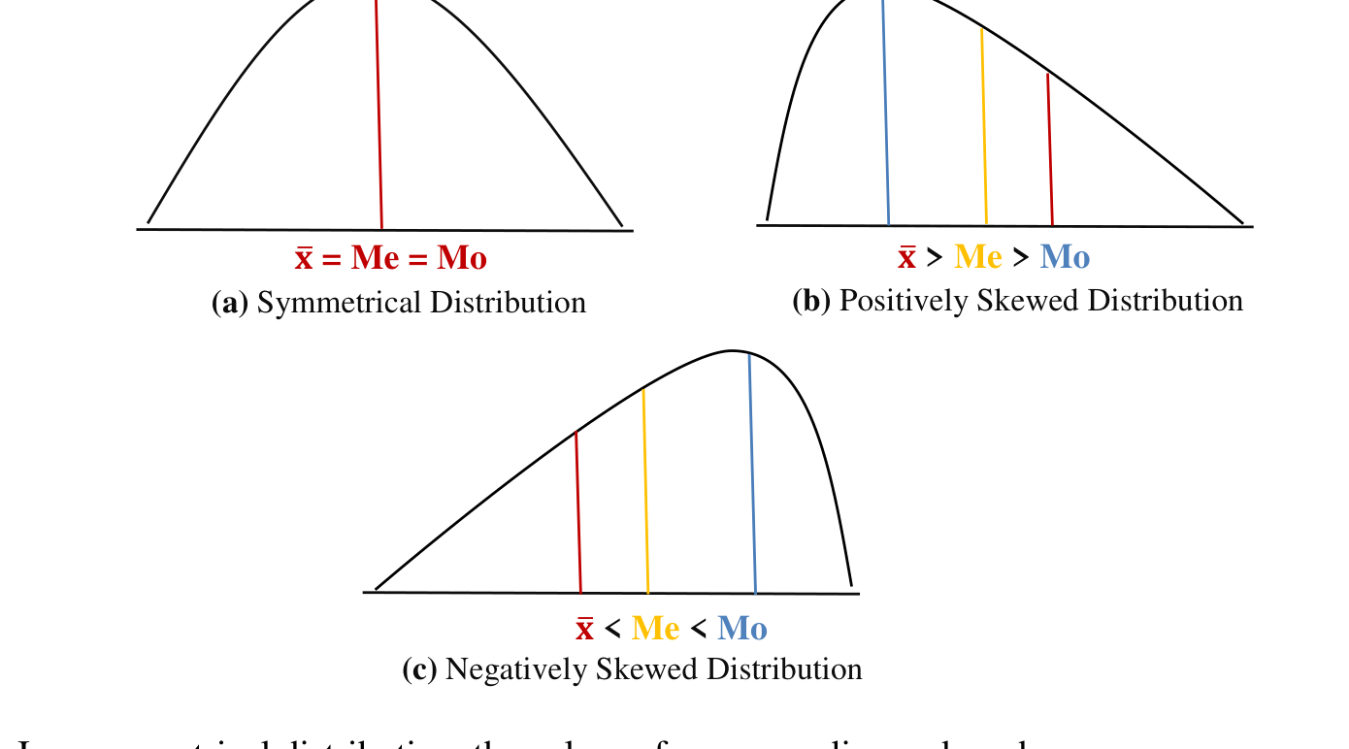
Figure 10.1 — Symmetric, positively and negatively skewed distributions (p. 1)
- Symmetric: mean = median = mode.
- Positively skewed: mean > median > mode (long right tail).
- Negatively skewed: mode > median > mean (long left tail).
Pearson: Sk_{P} = (Mean − Mode)/σ (or 3(Mean − Median)/σ)
Bowley: Sk_{B} = (Q₃ + Q₁ − 2Q₂)/(Q₃ − Q₁)
Kelly: Sk_{K} = (P₉₀ − 2P₅₀ + P₁₀)/(P₉₀ − P₁₀) = (D₉ − 2D₅ + D₁)/(D₉ − D₁)
Sign: > 0 positive, < 0 negative, 0 symmetric. Bowley lies in −1 to +1 (quartile based); Pearson is usually within ±1 (theoretically ±3 with the median form).

Slide examples (pp. 3–5)
Data | Mean | Mode | σ | Sk_{P} | Comment
Profits 100–240 (N = 1000) | 177.86 | 190.56 | 25.2 | −0.504 | moderately negatively skewed
Rejects 21–55 (N = 120) | 36.96 | 37.21 | 6.736 | −0.037 | slightly skewed to the left
Ages 20–55 (N = 100) | 37.25 | 36.67 | 8.29 | 0.07 | slightly positively skewed

Practice answers (pp. 6–7): 46.4/48.89/24.56/−0.101; 25.9/24.07/10.963/0.167; 33.156/32.63/17.08/0.031; 4781.5/4866.67/340.4/−0.25; −0.267; 30.1/27.73/10.45/0.227; 23.1/22.5/6.49/0.092; −0.023; −0.026; −0.572.
EXAM-READY ANSWER Merits and drawbacks (2020-21 Q5(b)): Bowley's coefficient uses only the quartiles, so it is easy to compute, works for open-ended classes and is not affected by extreme values, but it ignores the 50 % of the data outside Q₁–Q₃. Kelly's coefficient uses P₁₀ and P₉₀, so it covers the central 80 % — more of the data than Bowley — while still ignoring the extreme 10 % at each end. Pearson's coefficient uses every observation through the mean and σ but needs a well-defined mode (fails for bimodal data). Moment measures (γ₁) use all the data and are the most reliable.

Exam Approach
1. Find mean, σ (step deviation) and mode (Δ formula), or median when the mode is ill-defined.
2. Bowley/Kelly: cumulative frequencies, then Q1, Q2, Q3 (or D1, D5, D9) by the positional formula.
3. Substitute; state the sign and size (|Sk| < 0.1 nearly symmetric, 0.1–0.5 moderate, > 0.5 marked).

Practice — Lesson 10
(a) Actual — 2020-21 Q5(b) (TF p. 37). (b) Actual — 2012-13 Q6(a) (TF p. 5).
(a) Weights 30–40 … 80–90 with frequencies 18, 37, 45, 27, 15, 8. Calculate Bowley's and Kelly's coefficients of skewness, interpret, and discuss the merits and drawbacks of the methods. (15)
(b) Runs of A in 10 matches: 55, 80, 78, 49, 52, 76, 78, 76, 62, 76; of B: 54, 78, 55, 66, 63, 69, 74, 64, 59, 85. (i) Pearson's coefficient of skewness and kurtosis and Bowley's coefficient of skewness for B only; comment on the shape. (ii) If consistency is the criterion for a prize, who should get it? (15)

✔ Solution
(a) N = 150; cumulative frequencies 18, 55, 100, 127, 142, 150.
Q1: N/4 = 37.5 → class 40–50: Q1 = 40 + (37.5 − 18)/37 × 10 = 45.27
Q2: N/2 = 75 → class 50–60: Q2 = 50 + (75 − 55)/45 × 10 = 54.444
Q3: 3N/4 = 112.5 → class 60–70: Q3 = 60 + (112.5 − 100)/27 × 10 = 64.63
Sk_B = (64.63 + 45.27 − 2 × 54.444)/(64.63 − 45.27) = 0.0522
D1: N/10 = 15 → class 30–40: D1 = 30 + 15/18 × 10 = 38.333
D5 = median = 54.444
D9: 9N/10 = 135 → class 70–80: D9 = 70 + (135 − 127)/15 × 10 = 75.333
Sk_K = (75.333 − 2 × 54.444 + 38.333)/(75.333 − 38.333) = 0.1291

Both coefficients are positive: the distribution is slightly positively skewed (longer upper tail). Kelly's value (0.13) is larger than Bowley's (0.05) because it also reflects the long upper tail between Q₃ and D₉, which Bowley ignores. Merits/drawbacks: model answer above.
(b) B sorted: 54, 55, 59, 63, 64, 66, 69, 74, 78, 85; n = 10, Σx = 667, x̄ = 66.7.
Σ(x − x̄)² = 900.1 → σ = √(900.1/10) = 9.487; median = (64 + 66)/2 = 65
No value repeats, so the mode is not defined → use Pearson's second coefficient:
Sk_P = 3(Mean − Median)/σ = 3(66.7 − 65)/9.487 = 0.538
Moments about the mean: m2 = 90.01, m3 = Σ(x − x̄)³/10 = 379.54, m4 = Σ(x − x̄)⁴/10 = 17983.3
Kurtosis β2 = m4/m2² = 17983.3/90.01² = 2.22 (γ1 = m3/m2^1.5 = 0.444)
Q1 = value at (n + 1)/4 = 2.75th = 55 + 0.75(59 − 55) = 58; Q3 = 8.25th = 74 + 0.25(78 − 74) = 75
Sk_B = (75 + 58 − 2 × 65)/(75 − 58) = 3/17 = 0.176

B's runs are moderately positively skewed (Sk_{P} = 0.54, Sk_{B} = 0.18) and platykurtic (β₂ = 2.22 < 3). (ii) A: x̄ = 68.2, σ = 11.65, C.V. = 17.08 %; B: x̄ = 66.7, σ = 9.49, C.V. = 14.22 %. B is more consistent → the prize goes to B.

Lesson 11 — Moments, β₁, β₂, γ₁, γ₂ and Kurtosis
pp. 8–15

1. Moments (p. 8)
Raw (about A): μ'_{r} = Σf(x − A)^{r}/N = (Σfd^{r}/N) h^{r}
Central (about x̄): μ_{r} = Σf(x − x̄)^{r}/N; μ₁ = 0, μ₂ = σ²

2. Raw → Central Moments (pp. 9–10)
μ₂ = μ'₂ − μ'₁²
μ₃ = μ'₃ − 3μ'₂μ'₁ + 2μ'₁³
μ₄ = μ'₄ − 4μ'₃μ'₁ + 6μ'₂μ'₁² − 3μ'₁⁴
Proof idea (p. 9): write x − x̄ = (x − A) − (x̄ − A) with x̄ − A = μ'₁, expand by the binomial theorem and average term by term, e.g. μ₂ = μ'₂ − 2μ'₁μ'₁ + μ'₁² = μ'₂ − μ'₁².

3. Moment Measures of Skewness and Kurtosis (pp. 12–13)
β₁ = μ₃²/μ₂³, γ₁ = μ₃/μ₂^{3/2} (sign gives the direction)
β₂ = μ₄/μ₂², γ₂ = β₂ − 3
- Kurtosis = degree of peakedness relative to the normal curve.
- β₂ > 3 (γ₂ > 0): leptokurtic (more peaked); β₂ = 3: mesokurtic (normal); β₂ < 3: platykurtic (flatter).
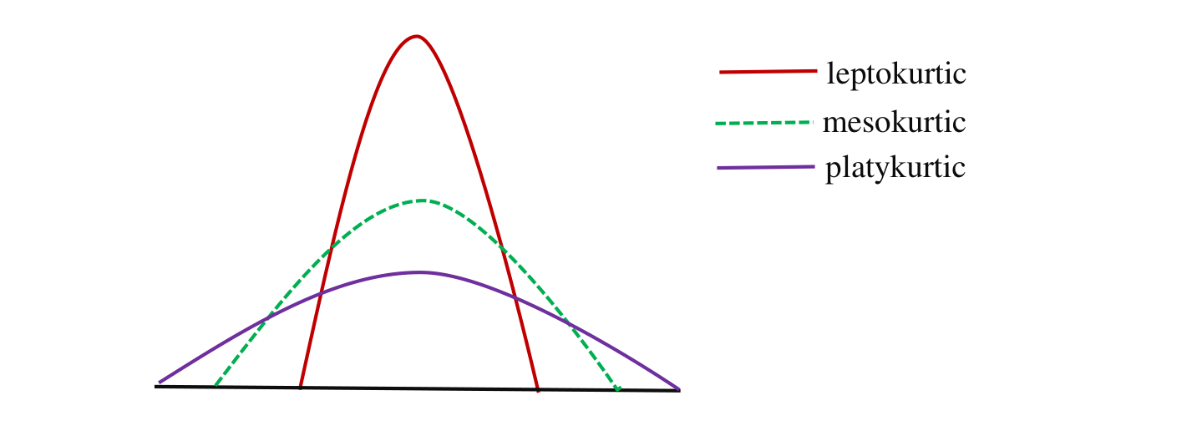
Figure 11.1 — Leptokurtic, mesokurtic and platykurtic curves (p. 12)
EXAM-READY ANSWER Definitions (2022-23 Q6(a), 2016-17 Q6(a), 2018-19 Q5(b)): Variance σ² — the mean of the squared deviations from the mean, Σf(x − x̄)²/N; SD σ — its positive square root, in the units of the data (e.g. wages with σ = Tk 8 vary about Tk 8 around the mean). Moments — μ_r = Σf(x − x̄)^{r}/N; the first four describe location, spread, asymmetry and peakedness. Skewness — departure from symmetry (income distributions are positively skewed). Kurtosis — peakedness relative to the normal curve (exam marks crowded at the mean → leptokurtic).

Exam Approach
1. Table: class, x, f, d = (x − A)/h, fd, fd², fd³, fd⁴; totals.
2. μ'_{1…4} = (Σfd^{r}/N)h^{r}.
3. μ₂, μ₃, μ₄ by the conversion formulas (keep 4 decimals; μ'₁ is negative when Σfd < 0).
4. β₁, β₂, γ₁, γ₂; comment on skewness (sign of μ₃) and kurtosis (β₂ vs 3).
5. If Pearson's coefficient is asked, also give mean, mode, σ and (mean − mode)/σ.

Practice — Lesson 11
(a) Actual — 2022-23 Q6(c) (TF p. 50); same table: 2018-19 Q5(b), 2016-17 Q6(a), 2014-15 Q6(b). (b) Actual — 2019-20 Q5(b) (TF p. 34). (c) Actual — 2023-24 Q6(a) (22 batch p. 3). (d) Actual — 2015-16 Q7(a) (TF p. 15) = 2013-14 Q6(b). (e) Actual — 2011-12 Q6(a) (TF p. 2).
(a) Profits (lakhs) 10–20, 20–30, 30–40, 40–50, 50–60 with 18, 20, 30, 22, 10 companies. Calculate the first four moments about an assumed mean, convert them to moments about the mean, compute γ₁ and γ₂ (β₁, β₂, Pearson's coefficient) and comment. (15–20)
(b) Earnings (Tk) 50–70 … 170–190 with 4, 8, 12, 20, 6, 7, 3 employees: first four moments about an assumed mean, moments about the mean, γ₁ and γ₂. (25)
(c) Marks 0–10 … 60–70 with 8, 12, 20, 30, 15, 10, 5 students: first four moments about the mean, β₁, β₂ and comment. (13)
(d) Classes 10–20 … 50–60 with frequencies 174, 86, 32, 181, 27: coefficients of skewness and kurtosis; comment. (18)
(e) Ages 21–26, 27–32, 33–38, 39–44, 45–50, 51–56 with 83, 75, 176, 130, 92, 54 persons: Pearson's first coefficient of skewness and kurtosis; comment. (20)

✔ Solution
(a) A = 35, h = 10, N = 100.
Profit | Mid x | f | d = (x − A)/h | fd | fd² | fd³ | fd⁴
10–20 | 15 | 18 | −2 | −36 | 72 | −144 | 288
20–30 | 25 | 20 | −1 | −20 | 20 | −20 | 20
30–40 | 35 | 30 | 0 | 0 | 0 | 0 | 0
40–50 | 45 | 22 | 1 | 22 | 22 | 22 | 22
50–60 | 55 | 10 | 2 | 20 | 40 | 80 | 160
Total |  | N = 100 |  | Σ = −14 | Σ = 154 | Σ = −62 | Σ = 490

μ'1 = (−14/100) × 10 = −1.4; μ'2 = (154/100) × 10² = 154
μ'3 = (−62/100) × 10³ = −620; μ'4 = (490/100) × 10⁴ = 49,000
μ2 = 154 − (−1.4)² = 152.04
μ3 = −620 − 3(154)(−1.4) + 2(−1.4)³ = 21.312
μ4 = 49,000 − 4(−620)(−1.4) + 6(154)(−1.4)² − 3(−1.4)⁴ = 47327.52
β1 = μ3²/μ2³ = 0.0001; γ1 = μ3/μ2^1.5 = 0.0114; β2 = μ4/μ2² = 2.0474; γ2 = −0.9526
Mean = 35 + (−14/100)(10) = 33.6; σ = √μ2 = 12.3305; Mode = 30 + 10/(10 + 8) × 10 = 35.5556
Pearson Sk = (Mean − Mode)/σ = (33.6 − 35.5556)/12.3305 = −0.1586

Comment: μ₃ > 0 so the distribution is positively skewed (only slightly, γ₁ = 0.011), and β₂ = 2.047 < 3 → platykurtic (flatter than normal). This matches the slide example on p. 11 (μ₄ = 47327.5).
(b) A = 120, h = 20, N = 60 (slide example pp. 14–15).
Earnings | Mid x | f | d = (x − A)/h | fd | fd² | fd³ | fd⁴
50–70 | 60 | 4 | −3 | −12 | 36 | −108 | 324
70–90 | 80 | 8 | −2 | −16 | 32 | −64 | 128
90–110 | 100 | 12 | −1 | −12 | 12 | −12 | 12
110–130 | 120 | 20 | 0 | 0 | 0 | 0 | 0
130–150 | 140 | 6 | 1 | 6 | 6 | 6 | 6
150–170 | 160 | 7 | 2 | 14 | 28 | 56 | 112
170–190 | 180 | 3 | 3 | 9 | 27 | 81 | 243
Total |  | N = 60 |  | Σ = −11 | Σ = 141 | Σ = −41 | Σ = 825

μ'1 = (−11/60) × 20 = −3.6667; μ'2 = (141/60) × 20² = 940
μ'3 = (−41/60) × 20³ = −5466.6667; μ'4 = (825/60) × 20⁴ = 2,200,000
μ2 = 940 − (−3.6667)² = 926.5556
μ3 = −5466.6667 − 3(940)(−3.6667) + 2(−3.6667)³ = 4774.7407
μ4 = 2,200,000 − 4(−5466.6667)(−3.6667) + 6(940)(−3.6667)² − 3(−3.6667)⁴ = 2195106.63
β1 = μ3²/μ2³ = 0.0287; γ1 = μ3/μ2^1.5 = 0.1693; β2 = μ4/μ2² = 2.5569; γ2 = −0.4431

Comment: μ₃ > 0 so the distribution is positively skewed (only slightly, γ₁ = 0.169), and β₂ = 2.557 < 3 → platykurtic (flatter than normal). The slide's γ₁ = 0.1693, γ₂ = −0.44 agree.
(c) A = 35, h = 10, N = 100.
Marks | Mid x | f | d = (x − A)/h | fd | fd² | fd³ | fd⁴
0–10 | 5 | 8 | −3 | −24 | 72 | −216 | 648
10–20 | 15 | 12 | −2 | −24 | 48 | −96 | 192
20–30 | 25 | 20 | −1 | −20 | 20 | −20 | 20
30–40 | 35 | 30 | 0 | 0 | 0 | 0 | 0
40–50 | 45 | 15 | 1 | 15 | 15 | 15 | 15
50–60 | 55 | 10 | 2 | 20 | 40 | 80 | 160
60–70 | 65 | 5 | 3 | 15 | 45 | 135 | 405
Total |  | N = 100 |  | Σ = −18 | Σ = 240 | Σ = −102 | Σ = 1440

μ'1 = (−18/100) × 10 = −1.8; μ'2 = (240/100) × 10² = 240
μ'3 = (−102/100) × 10³ = −1020; μ'4 = (1440/100) × 10⁴ = 144,000
μ2 = 240 − (−1.8)² = 236.76
μ3 = −1020 − 3(240)(−1.8) + 2(−1.8)³ = 264.336
μ4 = 144,000 − 4(−1020)(−1.8) + 6(240)(−1.8)² − 3(−1.8)⁴ = 141290.11
β1 = μ3²/μ2³ = 0.0053; γ1 = μ3/μ2^1.5 = 0.0726; β2 = μ4/μ2² = 2.5205; γ2 = −0.4795

Comment: μ₃ > 0 so the distribution is positively skewed (only slightly, γ₁ = 0.073), and β₂ = 2.521 < 3 → platykurtic (flatter than normal).
(d) A = 35, h = 10, N = 500.
Class | Mid x | f | d = (x − A)/h | fd | fd² | fd³ | fd⁴
10–20 | 15 | 174 | −2 | −348 | 696 | −1392 | 2784
20–30 | 25 | 86 | −1 | −86 | 86 | −86 | 86
30–40 | 35 | 32 | 0 | 0 | 0 | 0 | 0
40–50 | 45 | 181 | 1 | 181 | 181 | 181 | 181
50–60 | 55 | 27 | 2 | 54 | 108 | 216 | 432
Total |  | N = 500 |  | Σ = −199 | Σ = 1071 | Σ = −1081 | Σ = 3483

μ'1 = (−199/500) × 10 = −3.98; μ'2 = (1071/500) × 10² = 214.2
μ'3 = (−1081/500) × 10³ = −2162; μ'4 = (3483/500) × 10⁴ = 69,660
μ2 = 214.2 − (−3.98)² = 198.3596
μ3 = −2162 − 3(214.2)(−3.98) + 2(−3.98)³ = 269.4584
μ4 = 69,660 − 4(−2162)(−3.98) + 6(214.2)(−3.98)² − 3(−3.98)⁴ = 54846.29
β1 = μ3²/μ2³ = 0.0093; γ1 = μ3/μ2^1.5 = 0.0965; β2 = μ4/μ2² = 1.3939; γ2 = −1.6061
Mean = 35 + (−199/500)(10) = 31.02; σ = √μ2 = 14.084; Mode = 40 + 149/(149 + 154) × 10 = 44.9175
Pearson Sk = (Mean − Mode)/σ = (31.02 − 44.9175)/14.084 = −0.9868

Comment: μ₃ > 0 so the distribution is positively skewed (only slightly, γ₁ = 0.096), and β₂ = 1.394 < 3 → platykurtic (flatter than normal). The frequencies have two peaks (174 and 181), so the mode is ill-defined and Pearson's value (−0.99, using the Δ formula in 40–50) contradicts the moment measure; quote the moment coefficient γ₁ = 0.097 (nearly symmetric) and β₂ = 1.39 (strongly platykurtic — a U-/bimodal shape).
(e) Inclusive classes → boundaries 20.5–26.5, …, 50.5–56.5; mid-values 23.5, 29.5, …, 53.5; A = 41.5, h = 6, N = 610.
Age | Mid x | f | d = (x − A)/h | fd | fd² | fd³ | fd⁴
20.5–26.5 | 23.5 | 83 | −3 | −249 | 747 | −2241 | 6723
26.5–32.5 | 29.5 | 75 | −2 | −150 | 300 | −600 | 1200
32.5–38.5 | 35.5 | 176 | −1 | −176 | 176 | −176 | 176
38.5–44.5 | 41.5 | 130 | 0 | 0 | 0 | 0 | 0
44.5–50.5 | 47.5 | 92 | 1 | 92 | 92 | 92 | 92
50.5–56.5 | 53.5 | 54 | 2 | 108 | 216 | 432 | 864
Total |  | N = 610 |  | Σ = −375 | Σ = 1531 | Σ = −2493 | Σ = 9055

μ'1 = (−375/610) × 6 = −3.6885; μ'2 = (1531/610) × 6² = 90.3541
μ'3 = (−2493/610) × 6³ = −882.7672; μ'4 = (9055/610) × 6⁴ = 19238.1639
μ2 = 90.3541 − (−3.6885)² = 76.7489
μ3 = −882.7672 − 3(90.3541)(−3.6885) + 2(−3.6885)³ = 16.6864
μ4 = 19238.1639 − 4(−882.7672)(−3.6885) + 6(90.3541)(−3.6885)² − 3(−3.6885)⁴ = 13034.15
β1 = μ3²/μ2³ = 0.0006; γ1 = μ3/μ2^1.5 = 0.0248; β2 = μ4/μ2² = 2.2128; γ2 = −0.7872
Mean = 41.5 + (−375/610)(6) = 37.8115; σ = √μ2 = 8.7606; Mode = 32.5 + 101/(101 + 46) × 6 = 36.6224
Pearson Sk = (Mean − Mode)/σ = (37.8115 − 36.6224)/8.7606 = 0.1357

Comment: μ₃ > 0 so the distribution is positively skewed (only slightly, γ₁ = 0.025), and β₂ = 2.213 < 3 → platykurtic (flatter than normal).

Quick Notes — Skewness, Moments and Kurtosis
Revision points for Lessons 10–11.

L10 · Skewness
- Sk_P = (Mean − Mode)/σ or 3(Mean − Median)/σ; Bowley (Q3 + Q1 − 2Q2)/(Q3 − Q1); Kelly with D1, D5, D9.
- Weights: Bowley 0.052, Kelly 0.129 (slightly positive). Runs B: Sk_P 0.54, Bowley 0.18, β2 2.22; B wins (C.V. 14.2 %).

L11 · Moments and Kurtosis
- μ'_r = (Σfd^r/N)h^r; μ2 = μ'2 − μ'1²; μ3 = μ'3 − 3μ'2μ'1 + 2μ'1³; μ4 = μ'4 − 4μ'3μ'1 + 6μ'2μ'1² − 3μ'1⁴.
- β1 = μ3²/μ2³, γ1 = μ3/μ2^{3/2}; β2 = μ4/μ2², γ2 = β2 − 3; β2 < 3 platy, > 3 lepto.
- 18-20-30-22-10: μ2 152.04, μ3 21.31, μ4 47327.5, γ1 0.011, β2 2.05.
- Earnings: γ1 0.169, γ2 −0.443. Marks 0–70: β1 0.0053, β2 2.52. 174…27: γ1 0.097, β2 1.39. Ages: Sk_P 0.136, β2 2.21.

